**Experiment 10: Simple application using Ajax**

**Aim:** To make a simple application using Ajax.

**Implementation:**

**Output:**

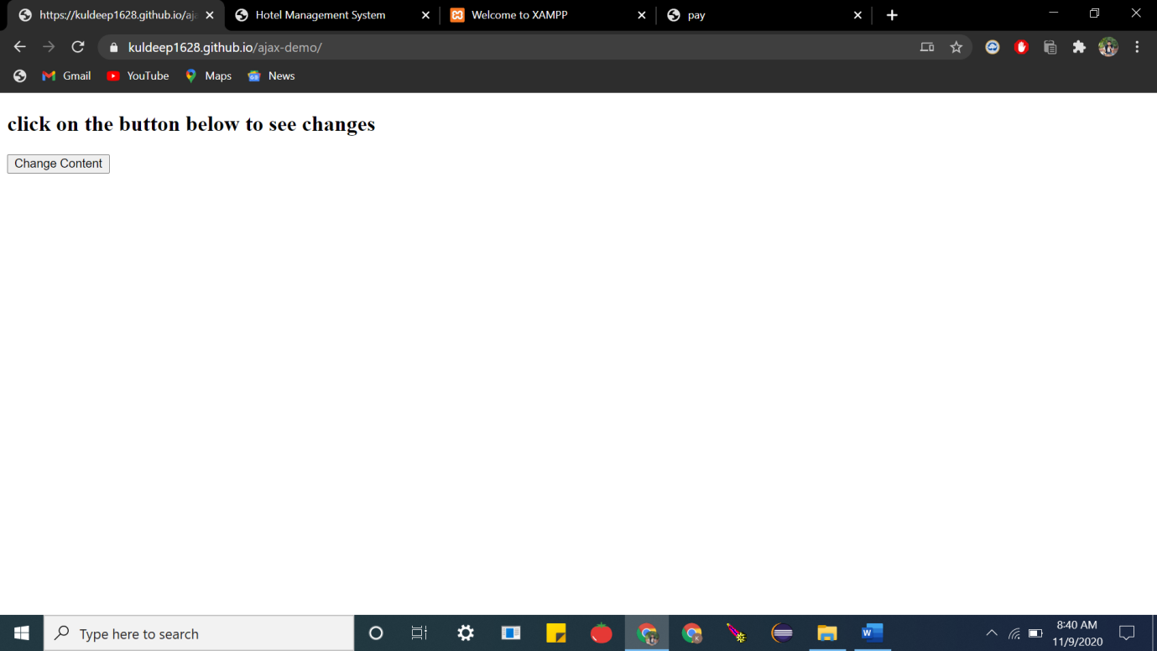

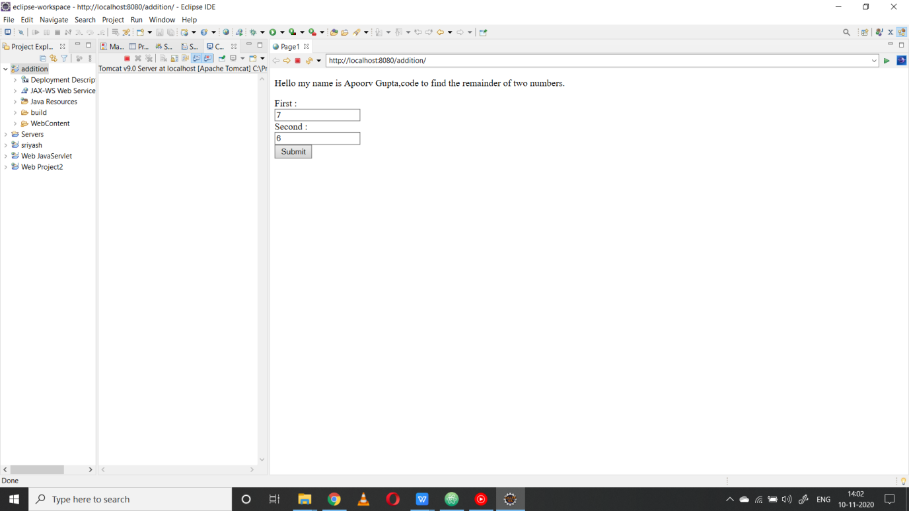

**Code:**

**INDEX.html**

|  |
| --- |
| <!DOCTYPE html> |
|  | <html> |
|  | <body> |
|  |  |
|  | <div id="demo"> |
|  | <h2>click on the button below to see changes</h2> |
|  | <button type="button" onclick="loadDoc()">Change Content</button> |
|  | </div> |
|  |  |
|  | <script> |
|  | function loadDoc() { |
|  | var xhttp = new XMLHttpRequest(); |
|  | xhttp.onreadystatechange = function() { |
|  | if (this.readyState == 4 && this.status == 200) { |
|  | document.getElementById("demo").innerHTML = |
|  | this.responseText; |
|  | } |
|  | }; |
|  | xhttp.open("GET", "ajax.html", true); |
|  | xhttp.send(); |
|  | } |
|  | </script> |
|  |  |
|  | </body> |
|  | </html> |

**index.html**

|  |
| --- |
| <%@ page language=*"java"* contentType=*"text/html; charset=ISO-8859-1"* |
| pageEncoding=*"ISO-8859-1"*%> | pageEncoding=*"ISO-8859-1"*%> |
| <!DOCTYPE html> | <!DOCTYPE html> |
| <html> | <html> |
| <head> | <head> |
| <meta charset=*"ISO-8859-1"*> | <meta charset=*"ISO-8859-1"*> |
| <title>Page1</title> | <title>Page1</title> |
| </head> | </head> |
| <body> | <body> |

**Result:**The experiment was successfully completed.